**EXERCISE-14**

**Question-1:-**

**Output:-**

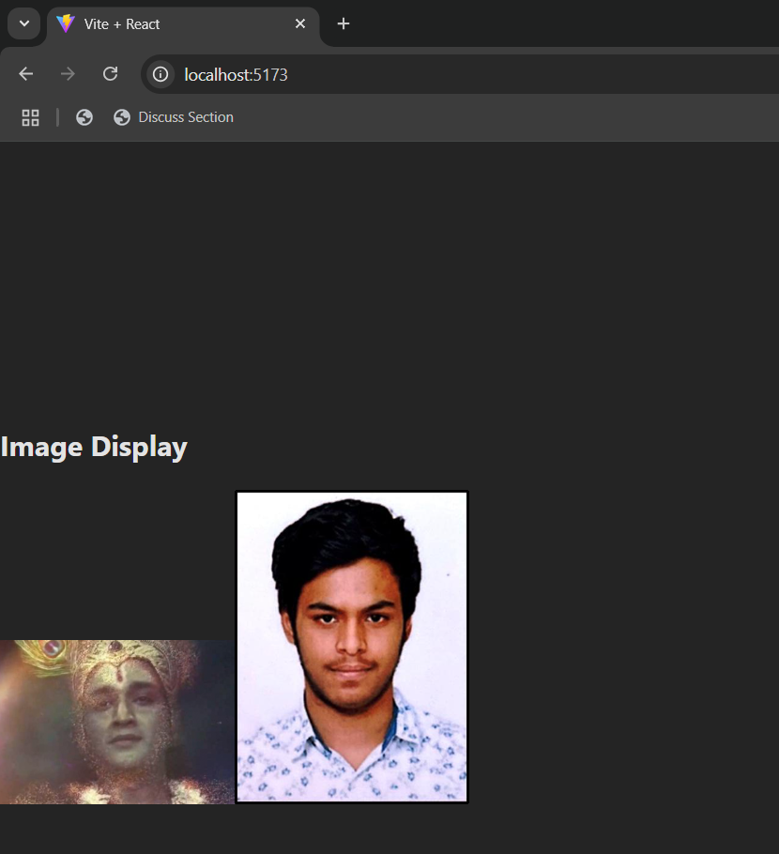

**Question-2:-**

**Output:-**

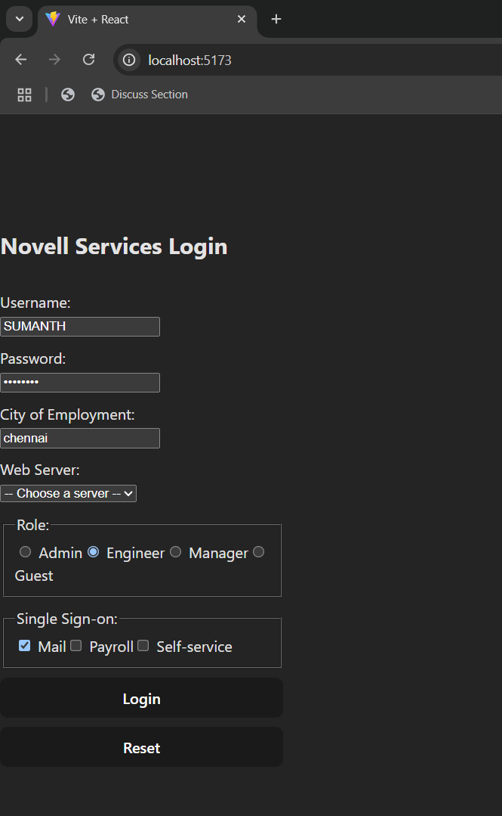

**Question-3:-**

**Output:-**

